**Упражнения для развития зрительного восприятия у**

**дошкольников**

**Найди и назови спрятанные изображения**

[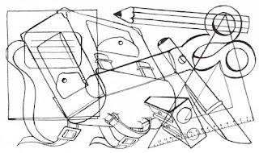](https://1.bp.blogspot.com/-nQ8qRSoJfPE/WZfDC_9xGOI/AAAAAAAAAUg/NS3NWDuTZ4k6-ad_Jt7UhcPx768tH29FQCLcBGAs/s1600/2a096d295c20d92a9ade02aaa9d68dd1.jpg.jpg)

[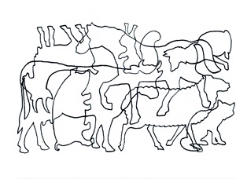](https://1.bp.blogspot.com/-3l9M1npCmug/WZfDCxMCPYI/AAAAAAAAAUY/hzPFk5cM_RszZgUnNkir5I8fo68NVK3KgCLcBGAs/s1600/135108d357bbe67d3717daf8a82c80b5.jpg)

[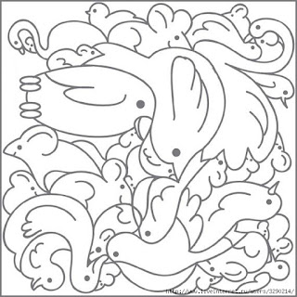](https://2.bp.blogspot.com/-uCS1abaC40k/WZfDDu_Lq0I/AAAAAAAAAUk/JwBl__9yiggPFaVNxAQ0_SsSQb1gUvycwCLcBGAs/s1600/57723998_ptizi01.jpg)[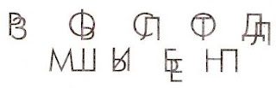](https://1.bp.blogspot.com/-83FGGVEJoHw/WZfFIaE6hCI/AAAAAAAAAVg/_zMqUycyRHQTcUxU8XQjVodyiAxK6N5fACLcBGAs/s1600/images+(2).jpg)

**Дорисуй вторую сторону**

[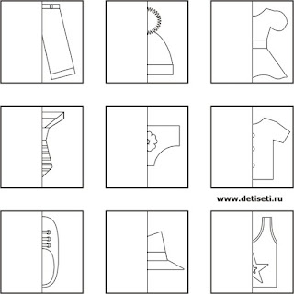](https://3.bp.blogspot.com/-4gY-k3ig-7A/WZfDDl70P3I/AAAAAAAAAUo/DpJmdUVlyrwOc93DUb7xDIwtdMJPwUERQCLcBGAs/s1600/86536534_clothes.jpg)[https://4.bp.blogspot.com/-gK74Yos6OE0/WZfFIXsGsRI/AAAAAAAAAVc/33WUB2BxJbs8XS59bDQ4SVSwWOhrbJIygCLcBGAs/s320/images%2B%25283%2529.jpg](https://4.bp.blogspot.com/-gK74Yos6OE0/WZfFIXsGsRI/AAAAAAAAAVc/33WUB2BxJbs8XS59bDQ4SVSwWOhrbJIygCLcBGAs/s1600/images+(3).jpg)

[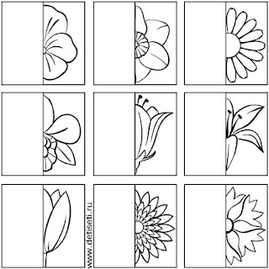](https://3.bp.blogspot.com/--UcNTtUdusY/WZfDD4kfODI/AAAAAAAAAUs/GRRyZbIywoYgenzSRe-8cil2A9YMAEZqACLcBGAs/s1600/86536535_large_cvety.jpg)

[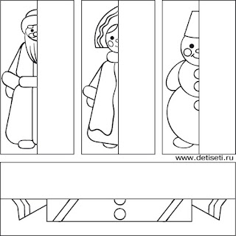](https://2.bp.blogspot.com/-BM9wF8zvArA/WZfDEDMoeUI/AAAAAAAAAUw/A_k9ytlPFDEbbhsoRcZ0tYdOyvvMK9kWACLcBGAs/s1600/86536536_dedsnegursneghlop01.jpg)

[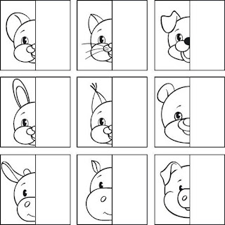](https://4.bp.blogspot.com/--sGJswwB-zA/WZfDEbIuYWI/AAAAAAAAAU0/IRBW4bZopKcupvMWfpEn0k8pRdFNg_gIACLcBGAs/s1600/hello_html_1f3f47bf.jpg)

[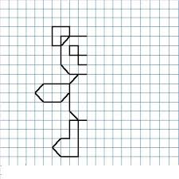](https://4.bp.blogspot.com/-SDXSQ2kppAo/WZfDEXUdSII/AAAAAAAAAU4/KOAbEu914f85tSF7Gr0v6LUcBsYATSluwCLcBGAs/s1600/images+(1).jpg)

[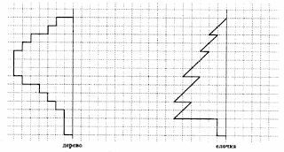](https://4.bp.blogspot.com/-2FWtwZfRJXA/WZfDEyx3_eI/AAAAAAAAAU8/LaSPFkQctho4pHvoRsTcGPXWbLI7laGiQCLcBGAs/s1600/iq08b.gif)

[](https://2.bp.blogspot.com/-ssrhH5UeTC8/WZfFHyjg1eI/AAAAAAAAAVQ/u_PFR6AtNKQhDZGvgsujkGWGdf-C5bh9wCLcBGAs/s1600/3da39006.jpg)

**Назови зачеркнутые изображения**

[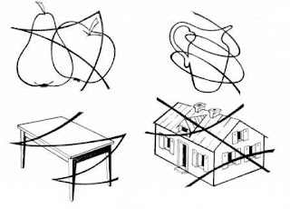](https://3.bp.blogspot.com/-PYW-XLGEikI/WZfFH4wSmeI/AAAAAAAAAVU/gb23rEMakbQiZ5ET7TGNPAavxbvukiwvwCLcBGAs/s1600/0_5678a_bc2d1e58_XXXL.jpg)

[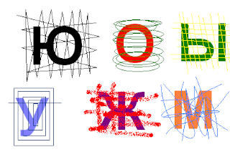](https://4.bp.blogspot.com/-bdiVuiFCd08/WZfFHmFJyLI/AAAAAAAAAVM/Kjbp9PlyzRonBgFO01tBH46nn1Ba7HTtQCLcBGAs/s1600/0016-026-Zashumlennye-bukvy-nalozhennye-drug-na-druga.png)

[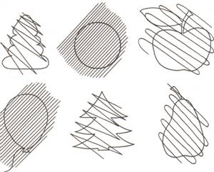](https://2.bp.blogspot.com/-yfHMVbUNqsM/WZfFIbBtDDI/AAAAAAAAAVY/IGbgEsV_xnULqRFGKkHn0-9mF1RyMW81ACLcBGAs/s1600/image006.jpg)